SYNOPSIS
Md. Abu Zafar Al Munsur
Department of Chemistry,
University of Rajshahi.
Rajshahi-6205
Student Id: 08014596
12-Aug-15
Supervisor
Prof. Dr. Harendra Nath Roy
Depeartment of Chemistry,
University of Rajshahi,
Rajshahi-6205

Rapid Access of Some Tri- and Tetra-Substituted Imidazoles from Benzil Condensed with Aldehydes and Ammonium Acetate Catalyzed by 3-Picolinic Acid.

Abstract
3-Picolinic acid has been found to be an efficient organocatalyst for one-pot synthesis of 2, 4, 5-triaryl substituted imidazoles. Moreover, the utility of this protocol has further been explored conveniently for the one-pot, four components Synthesis of 1, 2, 4, 5-tetrasubstituted imidazoles. The key advantages of this process are high yield, cost effectiveness catalyst, easy purification technique and above all environmentally benign.

Reaction Scheme

Introduction
Today, multicomponents reactions have created unusual sensation specially in the field of organic synthesis. Because with the help of this reaction some straightforward outcomes are obtained today, remarkably in the field of biologically active molecules, some complicated natural products, and in some cases total synthesis of some antibiotics has been achieved. Recently, chemists are trying to coplete the multicomponent strategy without any solvent or into a green solvent. Meanwhile, huge works has been emerged out by three component reaction strategies in synthesizing large numbers of some life controling drugs. Ionic liquids, Ceric Ammonium Nitrate(CAN), InCl₃.3H₂O, NiCl₂.6H₂O, ZnO-nano tube, nano-TiCl₄/SiO₂, BF₃•SiO₂, ammonium metavanadate, cellulose sulfuric acid, boric acid, Yb(OTf)_{3,} potassium aluminum sulfate, P-tolune sulfonic acid(P-TSA), ZrOCl₂•8H₂O, K₅CoW₁₂O₄₀•3H₂O, AcOH, KH₂PO_{4,} PEG-400, zeolite-HY/silica gel, ZrCl₄, sodium bisulfite, NH₄OAc, iodine, and microwave irradiation techniques were successfully employed to trisubstituted and tetrasubstituted imidazoles with great ease. But, by considering the demands of different tri-and tetrasubstituted imidazoles in the pharmaceuticals and to obviate the problems of the avilable procedures, has evisaged the chemists to adopt newer methods comparatively better in the sense of cost, yield and to the environment. Today, organocatalysts has drawn much attention in different organic reactions due to experimental simplicity, ease of handling, cost efffectiveness and excellent solubility in organic solvents and in water. A few examples of the multicomponents reactions mediated by organocatalysts were available in the literature. So, in view to obtain tri- and tetra substituted imidazoles here we have adopted a multicomponent strategy with benzil, aldehydes, ammonium acetate, aniline and benzylamine in the presence of 3-picolinic acid. Although 3-picolinic acid is less popular as organocatalyst in the organic synthesis but herein, we have tried to exploit it first time in the multicomponent reaction. Surprisingly, this organocatalys is acting well to various substituted imidazole synthesis with great ease and high yields.

Result & Discussion
We have attempted to prepare substituted imidazoles mediated by some small bifunctional molecules(o-aminophenol, 2-picolinic acid, aspartic acid, from benzil and antthranilic acid) aldehydes and ammonium acetate in water and ethnol solvent (1:1) system. Reacting components were mixed thoroughly according to their molar ratios and gently heated the mixture in an oil bath. The reaction mixture was diluted by distilled water and seperated by filtration. Recrystallization of the crude precipitates from ethanol gave pure product in 95% yield. Sevaral spectral data were taken which are all firmly indicating the formation of tri-substituted imidazoles. Some of the products were known in the literature, so in those cases only melting points were recorded to proof the formation of substituted imidazoles. Seventeen different imidazoles were prepared (table-1) without any sophisticated purification by column chromatographic techniques, or any other procedures. Yields are very high and the method is environmentally benign. So, this method could be used as a contending procedure in synthesizing many substituted imidazoles in a very easy and faster way.

General Procedure
A mixture of benzil (2 mmol), aldehyde (2 mmol), ammonium acetate (5 mmol) and 3-Picolinic acid (10 mol %) in water and ethanol (1:1, 2 mL) was stirred at reflux temperature for 2~3 hr. The progress of the reaction was monitored by TLC. All synthesized compounds were characterized with ¹H NMR and ¹³C. Also the melting points recorded were compared with the corresponding literature melting points and found to be matching with those. The representative analytical data for
4-(4, 5-Diphenyl-1H-imidazol-2-yl)-phenol (MSE-9): Mp. 267–269°C. ¹HNMR (DMSO-d₆, 500MHz): 12.4 (s, 1H, NH), 9.7 (s, 1H, OH), 7.9 (d, J¼8.5 Hz, 2H), 7.5 -7.2 (m, 10H, Ar-H), 6.9 (d, J¼8.5 Hz, 2H); ¹³C NMR (300 MHz, DMSO-d₆): 158.2, 146.5, 137.0, 135.848, 131.8, 130.0, 129.1, 128.8, 128.9, 128.6, 127.9, 127.8, 127.5, 127.3, 126.8, 122.1, 115.9 ppm.
4-(1-benzyl-4, 5-diphenyl-1H-imidazol-2-yl)-N, N-dimethylaniline (MSE-20): Mp.270-272⁰ C; ¹H NMR (500 MHz, DMSO-d₆): 7.6 (dd, J½ 1.5 Hz, J⅓ 8.5 Hz, 2H Aniline-H), 7.6 (dd, J½ 2 Hz, J⅓ 7 Hz, 2H Ar-H), 7.3-7.1 (m, 11H Ar-H), 6.9 (t, J½ 2 Hz, J⅓ 8 Hz, 2H Ar-H), 6.7 (dt, J½ 2 Hz, J⅓ 8 Hz, J¼ 9.5 Hz, 2H), 5.2 (s, 2H, CH₂), 3.0 (s, 6H, CH₃); ¹³C NMR (300 MHz, DMSO-d₆): 150.8, 148.8, 137.9, 131.3, 131.1, 129.4, 128.5, 128.0, 127.2, 126.9, 126.0, 112.0, 100.0, 48.3, 40.3 ppm.

Table-1
3-Picolinic acid catalyzed synthesis of tri- and tetra- substituted imidazoles.
Entry | Compound | Aldehydes  & Ammines | Time (min) | Yield (%) | M.P. (ºC)
01 | MSE-3 |  | 155 | 95 | 262-264
02 | MSE-4 |  | 130 | 96 | 230–232
03 | MSE-5 |  | 120 | 94 | 230–232
04 | MSE-8 |  | 125 | 95 | 230-231
05 | MSE-9 |  | 135 | 96 | 268-270
06 | MSE-10 |  | 120 | 90 | 199-200
07 | MSE-11 |  | 125 | 97 | 257-259
08 | MSE-12 |  | 110 | 90 | 210-212
09 | MSE-15 |  | 115 | 98 | 230-232
10 | MSE-16 |  | 120 | 99 | 199-201
11 | MSE-17 |  | 130 | 96 | 260-262
12 | MSE-19 | & | 120 | 98 | 279-281
13 | MSE-20 | & | 125 | 97 | 270-272
14 | MSE-21 | & | 120 | 98 | 247-248
15 | MSE-23 | & | 130 | 96 | 220-222
16 | MSE-25 | & | 125 | 97 | 257-258
17 | MSE-26 | & | 120 | 95 | 237-239

Spectra
MSE-9:
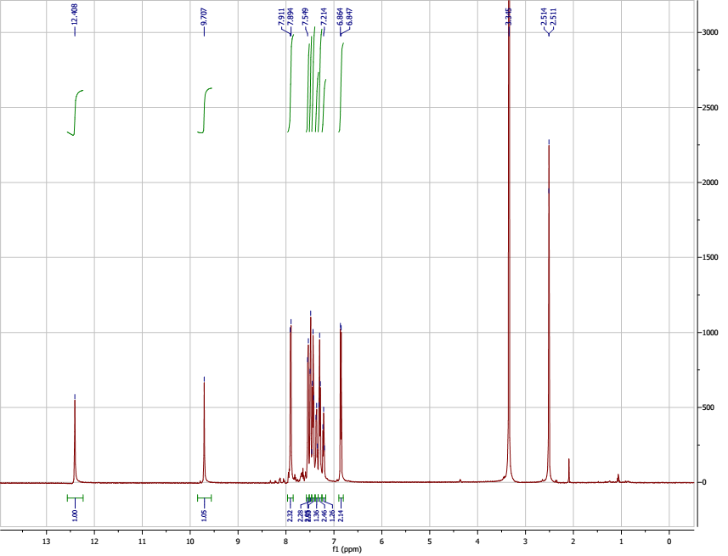
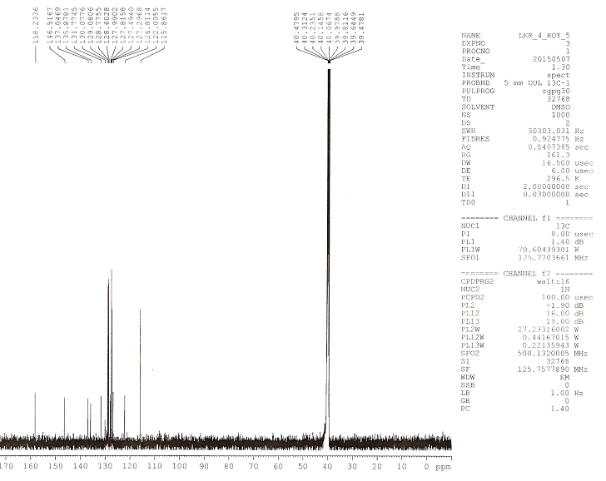
MSE-20:
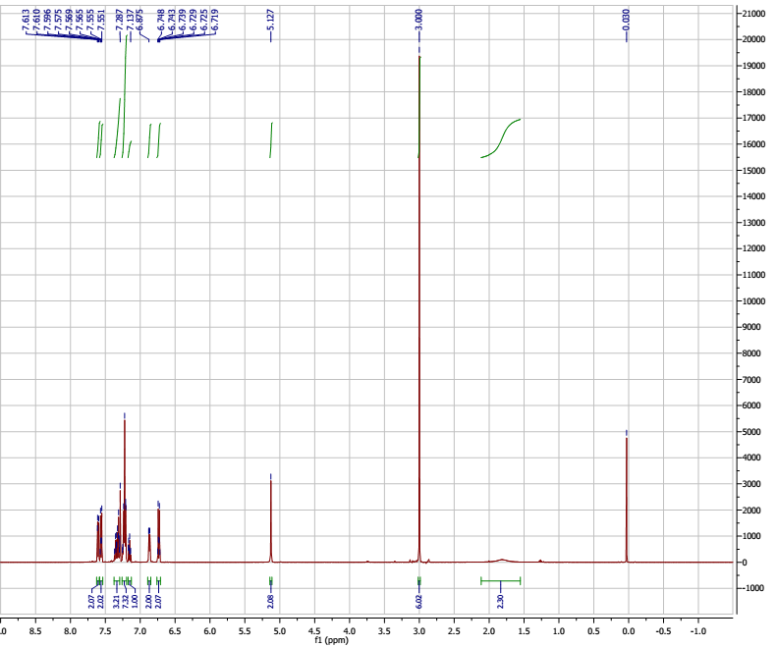

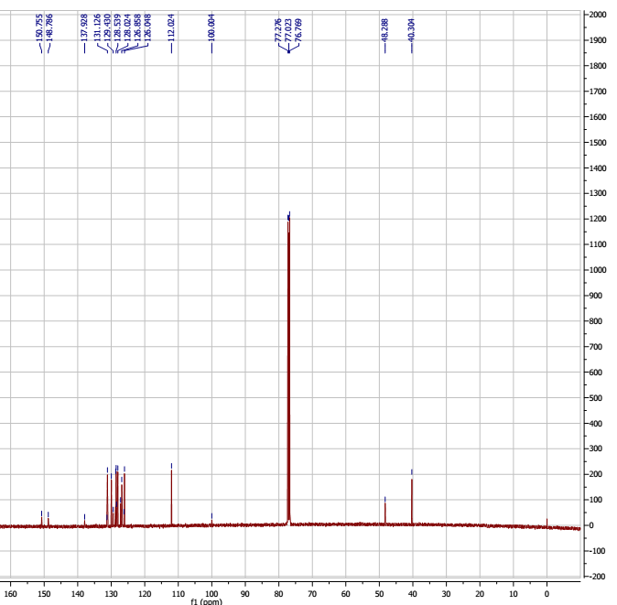

Summary & Future Plane
The study describes an efficient, rapid and convenient synthesis of tri- and tetra substituted imidazoles in a one pot, three and four component coupling reaction strategy using inexpensive, nontoxic ans easily available 3-picolinic acid as an organocatalyst in ethanol/Water(1:1). The present method offers several adgvantages including shorter reaction times at reflux temperature, higher yields, and easy experimental workup procedure. Besides, tolerability of the various substituents present in the aromatic aldehydes were observed, Thus, this simple method could be used as a contending method for the highly substituted imidazoles systems.

Aknowledgement
I am very grateful to my reverend supervisor “Prof. Dr. Harendra Nath Roy” and thankful to the honorable Chairman, Department of Chemistry, University of Rajshahi for providing the laboratory facilities. I am also especially thankful to “Dr. kee-In Lee” for giving spectroscopic (¹HNMR & ¹³C) data.

Reference
- Roy, H. N.; Rahaman, M. M.; Pramanick, P. K. Ind. J. Chem. 2013, 52B, 153-159.
- Shingare M. S. Shitole, N. V.; Shelke, K. F.; Sonar, S. S.; Sadaphal, S. A.; Shingate, B. B. Bull. Korean Chem. Soc. 2009, 30, 1963-1966.
- Dalko, P. I.; Moisan, L. Angew. Chem. Int. Ed. Engl. 2004, 43, 5138–5175.
- Dalko, P. I.; Moisan, L. Angew. Chem. Int. Ed. Engl. 2001, 41, 3726–3748.
- Leschke, C.; Elz, S.; Garbarg, M.; Schunack, W. J. Med. Chem. 1995, 38, 1287–1294.
- Almirant, L.; Polo, L.; Mugnaini, A.; Provinci, E.; Rugarli, P.; Biancott, A.; Gamba, A.; Murmann, W. J. Med. Chem. 1965, 8, 305–312.
- Sharma, S. D.; Hazarika, P.; Konwar, D. Tet. Lett. 2008, 49, 2216–2220.
- Black, J.W.; Durant, G.J.; Emmett, J.C.; Ganellin, C.R. Nature 1974, 248, 65–67.
- Dupont, J.; de Souza, R. F.; Suarez, P. A. Z. Chem. Rev.2002, 102, 3667–3692; (b) Anastas, P. T.; Warner, J. C.; In Green Chemistry: Theory and Practice, (Oxford University Press, Oxford, Uk) 1998; (c) Anastas, P.T.; & Williamsion, T.; In Green Chemistry: Frontiers in benign Chemical Synthesis and Process, (Oxford University Press, Oxford, Uk) 1998.

